**HW 5**

1. **According to the scatter plot below, we can see that for the control group, the relationship between before and after is roughly linear, while the relationship between before and after for the treatment group shows a curvilinear pattern.**

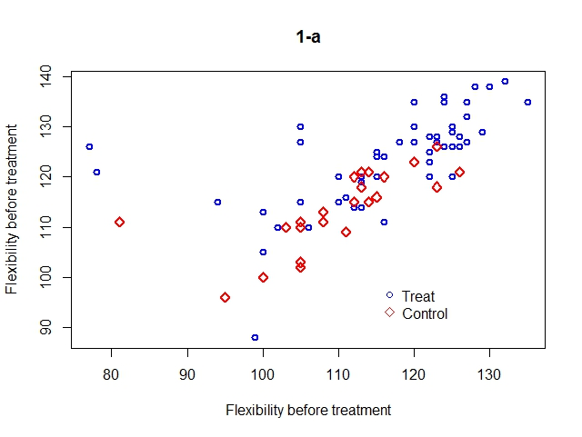

1. **According to the summary below, there’s a significant treatment effect, in that the p-value for this regression coefficient is less than 0.05 (p-value = 0.000165). The flexibility before as well as the intercept are also significant at α= 0.05. Therefore, flexibility before and the treatment are both significant predictors for flexibility after.**

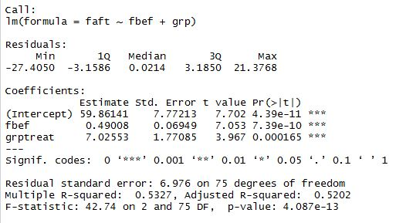

1. **According to the output below, No. 36 and No. 50 are considered outliers.**



1. **According to the model summary below, there’s a significant treatment effect, because the p-value for the corresponding regression coefficient is less than 0.05 (p-value = 0.00194).**

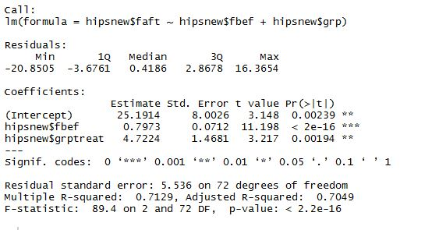

1. **According to the model summary above, the estimated size of the treatment effect is 4.72. The 95% CI for the effect is (1.796, 7.649).**



1. **Summary**

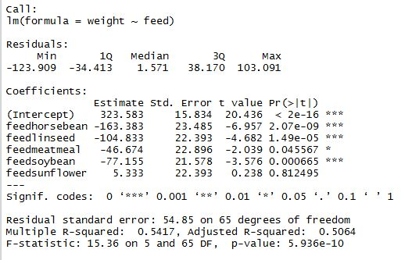

1. **According to the diagnostic plots below, we can conclude that there’s no big problem with linearity and constant variance (Residual vs Fitted has a roughly flat line, and points spread equally vertically; Scale-Location has a roughly flat line). The normality assumption holds because the points are on a straight line in the Q-Q plot. Residual-Leverage plot indicates no problems with outliers or too influential observations.**

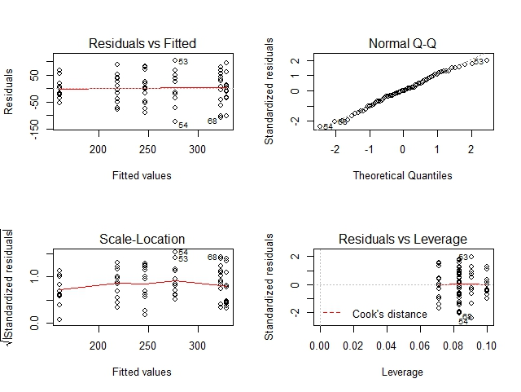

1. **ANOVA table**

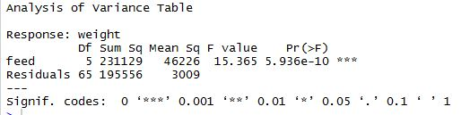

1. **Group comparison: according to the output below, there is a significant difference between the mean weights of the groups, in that the F-statistic has a p-value smaller than 0.05.**

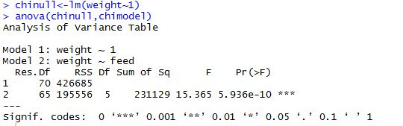

1. **Tukey simultaneous 95% CI:**

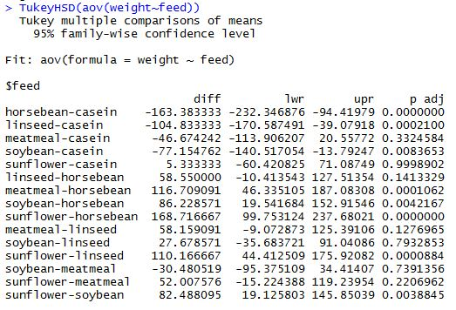

1. **According to the output above, the pairs that have significantly different means are :**

horsebean-casein

linseed-casein

soybean-casein

meatmeal-horseben

soybean-horsebean

sunflower-horsebean

sunflower-linseed

sunflower-soybean